**LAB # 07**

**OPEN ENDED LAB**

**OPEN-ENDED LAB TASK: GITHUB INTEGRATION, CODE OPTIMIZATION, AND CONCURRENCY IN JAVA**

**Objective**: In this lab, you will explore essential practices for version control using GitHub, practice code optimization techniques, and understand multithreading and inter-thread communication in Java.

**Task Instructions:**

1. **Implement Good Code Practices and Optimization Techniques**

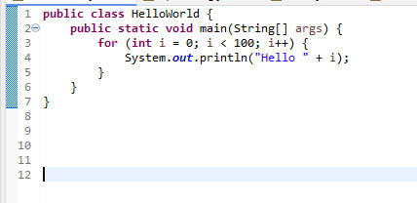

output

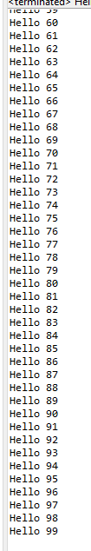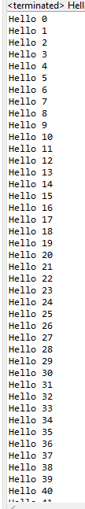

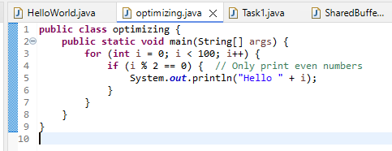

Output

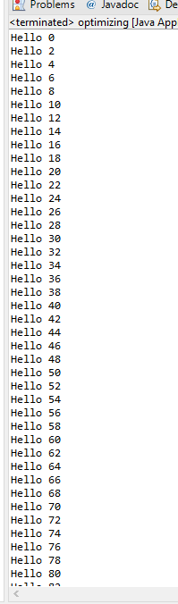

1. **Concurrency with Multithreading Mechanisms**

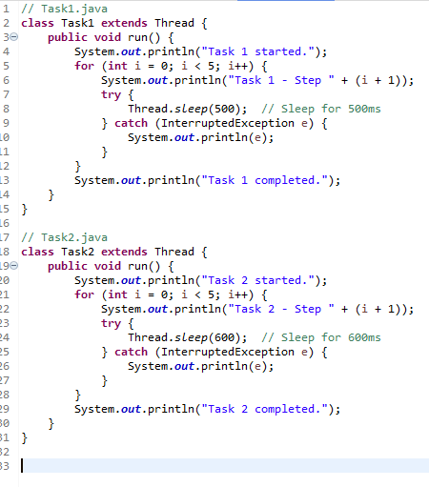 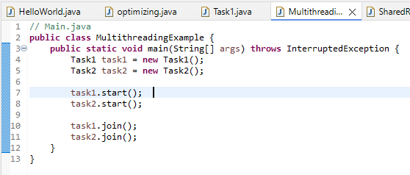

Output

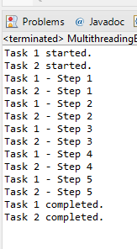

1. **Inter-Thread Communication Using Synchronization**

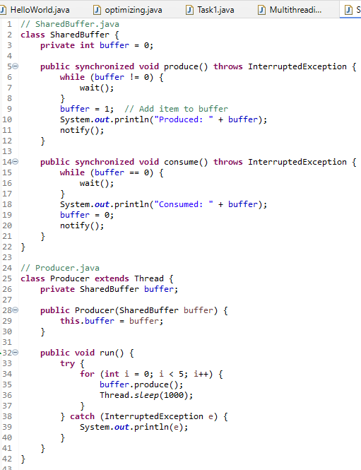 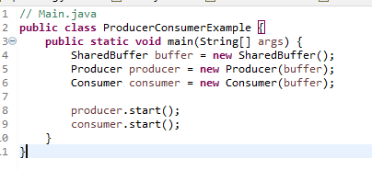

Output

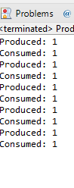

**Additional Challenge:**

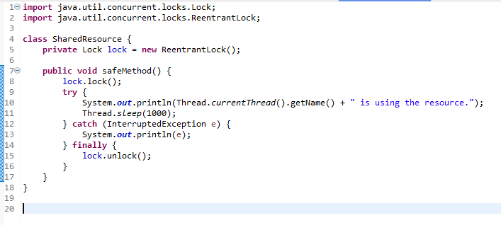

**Evaluation Criteria:**

* **Version Control Mastery**: Correctly perform commit, push, pull, and merge operations with clear documentation.
* **Code Quality**: Demonstrates effective refactoring and optimization techniques.
* **Concurrency Implementation**: Effective use of start, sleep, stop, join, synchronization, and thread-safe communication.
* **Documentation**: Clear and concise explanations of each part of the lab, including screenshots or logs as needed.